UNITED NATIONS DEVELOPMENT PROGRAMME  NIGERIA COUNTRY OFFICE |  |  |  | ONE PAGE MISSION REPORT SUMMARY  Dates: 19 – 23June 2017
Name:  - Anthony Omata  - Josephine Edwards |  | Unit: M&E and PFT units | Extension No. | Travel Authorization Number:
Approved Mission Itinerary  Abuja – Niger  Niger – Abuja  Abuja – Gombe  Gombe - Abuja | Mission Title  UNDP/BOI Solar Energy Project Phase I; Visit to sites in Niger and Gombe states.
Participants
- Ruseh Oghenekaro (BOI)
- Anthony Omata(UNDP)
- Josephine Edwards(UNDP)
Background
The UNDP/BOI field visit was to validate the procurement and instalment of solar equipment communities in Niger and Gombe states as below;

- State: Niger
- Date of mission: 19 – 20 June 2017
- Project Sites: (i)Swasun community, Katcha LGA, (ii) Mantutu community, Katcha LGA

  - State: Gombe
  - Date of mission: 21 – 23 June 2017
  - Project Sites: (i)Kolako community, Balanga LGA, (ii) Ayaba community, Billiri LGA

These communities at present are not connected to the national grid and depends mainly on fuelwood for energy use.

Findings

Niger State
- All items were available on site for both communities except for the items below;
  - Solar panels – These are been imported and should be available mid-July based on information from supplier.
  - Power House Construction - This will be completed in mid-July.
  - Thunder Arrestor – This will be provided when the power house in constructed.

- Completion date for both sites in Niger state is 2nd week of August

Gombe State
- Equipment arrived at Gombe site on the day of verification. All items were available for both communities except for the items below;
  - Solar panels – These are been imported and should be available mid-July based on information from supplier.
  - Power House Construction - This will be completed in early August.
  - Thunder Arrestor – This will be provided when the power house in constructed

- Completion date for site in Gombe is (Kolaku community-ending of August and Ayaba community- mid September)

Next Steps/Actions
- UNDP project team to follow up very closely with BOI to ensure solar panels are delivered as scheduled.
- UNDP to also ensure field visits are scheduled against timelines to ensure installation is completed as agreed.

Pictures

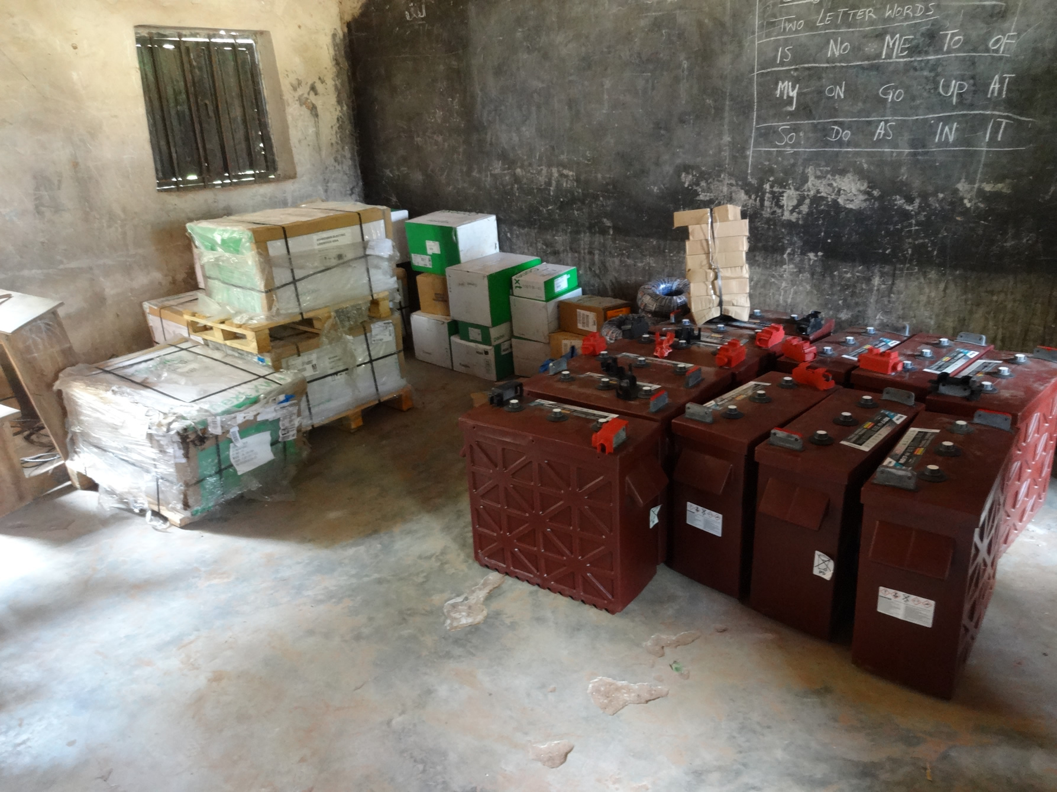
Cross-section of some equipment at Niger state site
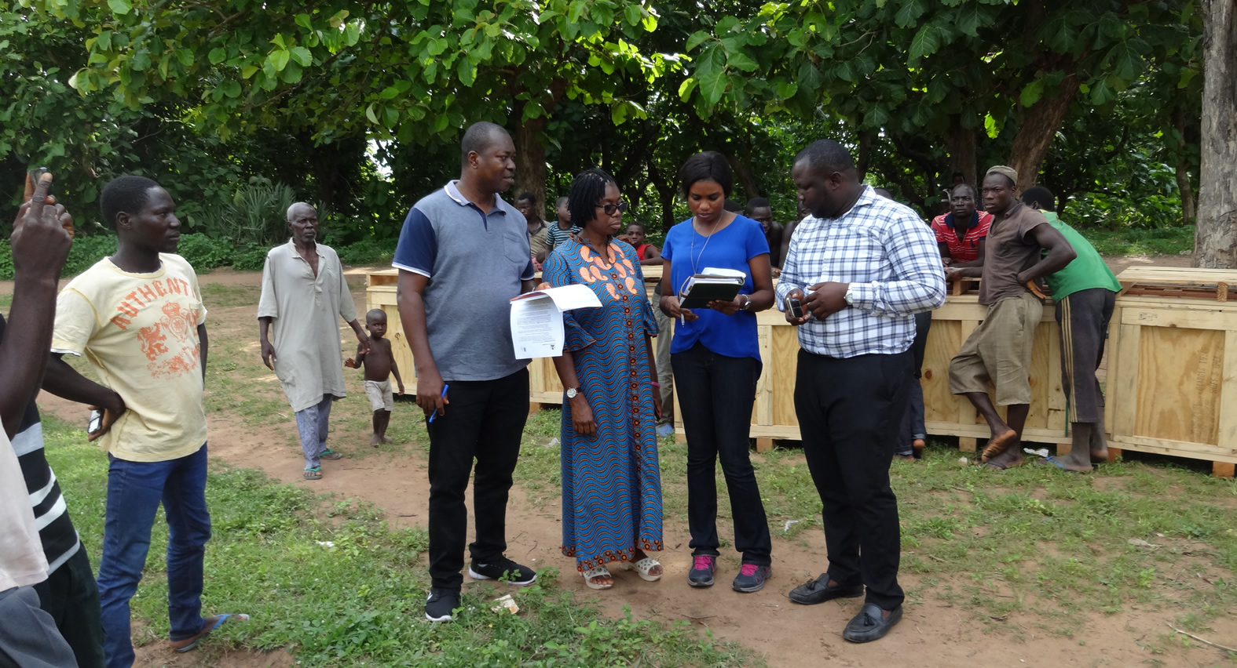
Verification in progress by UNDP, BOI and supplier at Niger state site
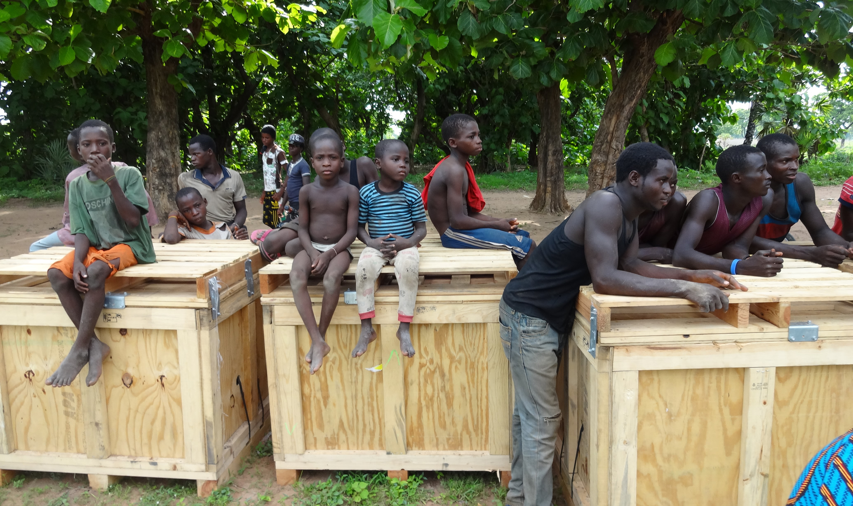
Waiting patiently…! Some young members of the community waiting for batteries to be dismantled from shipment casing at Niger state site
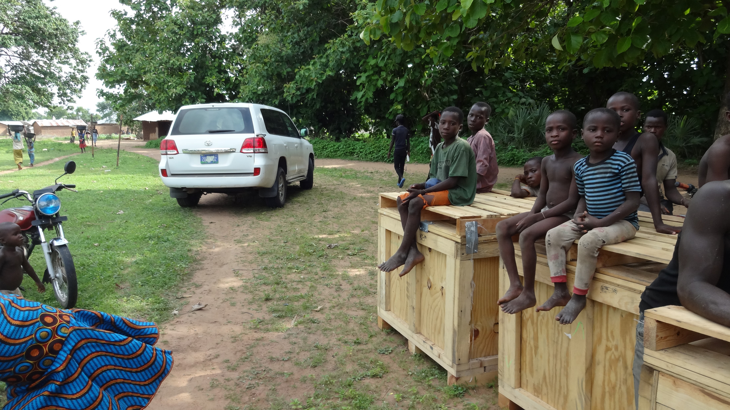
Some young members of the community waiting for batteries to be dismantled from shipment casing at Niger state site

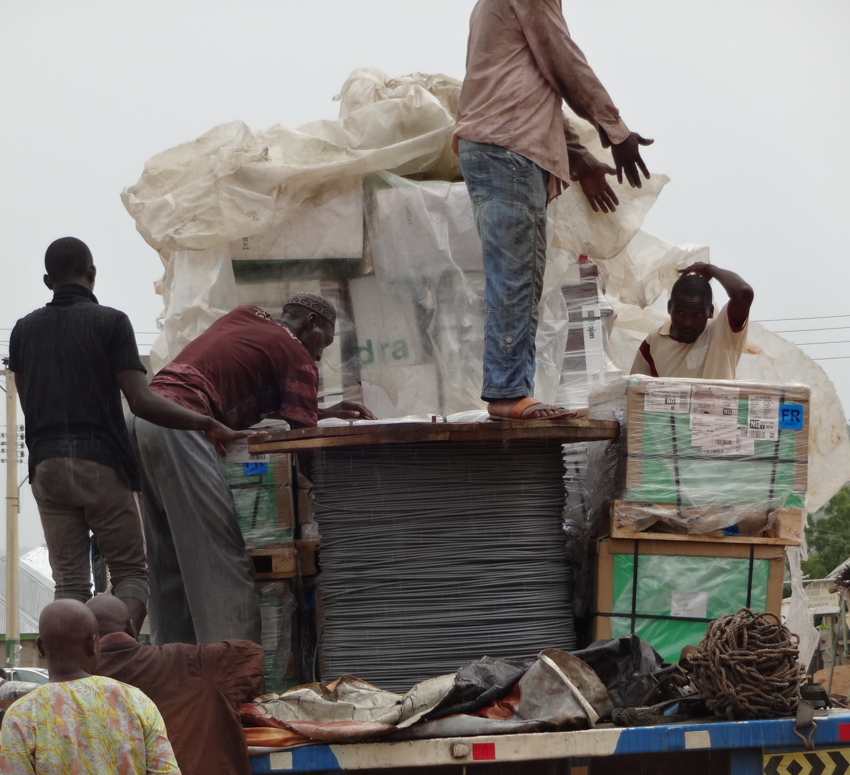
Off-loading some equipment at Gombe state site
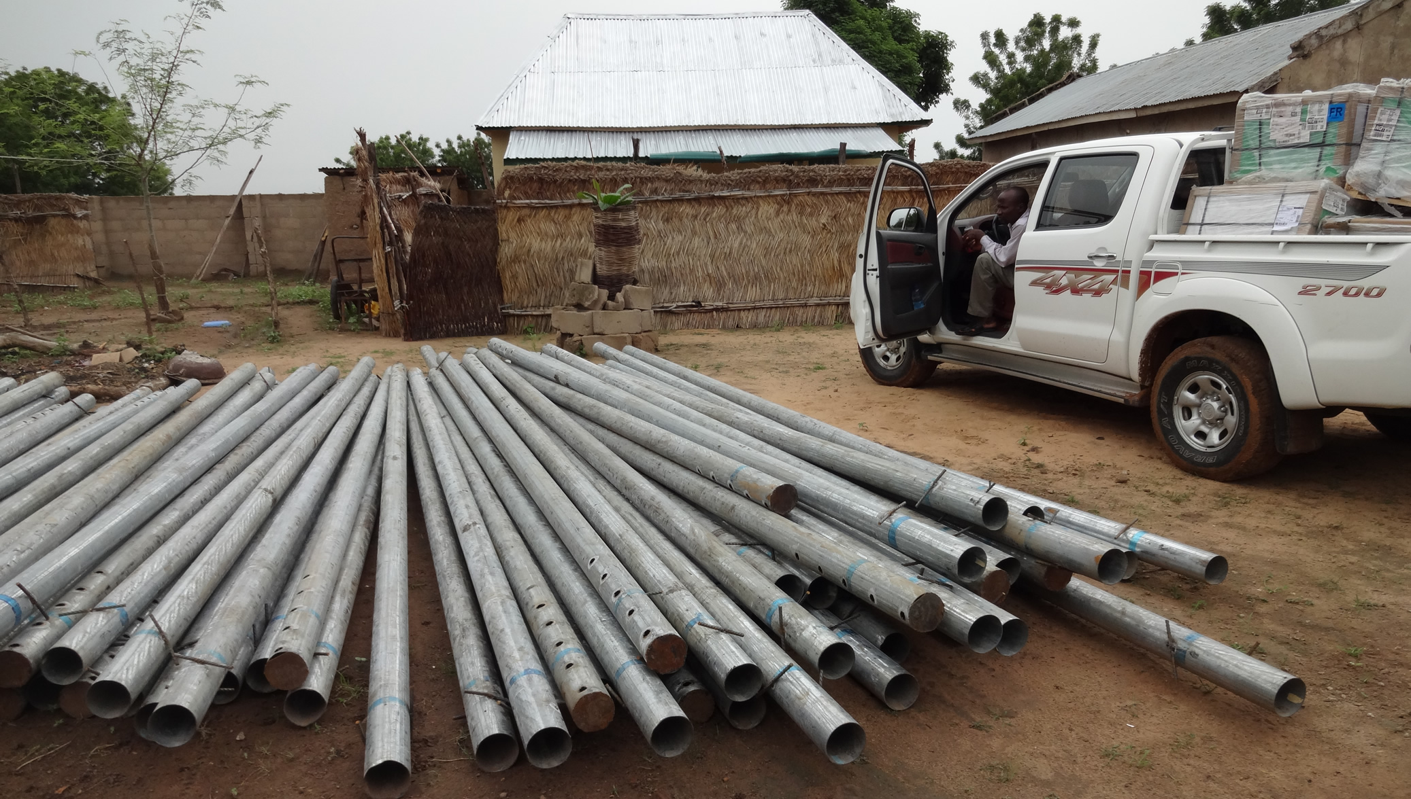
Some equipment at a district head’s house for safe keeping before installation

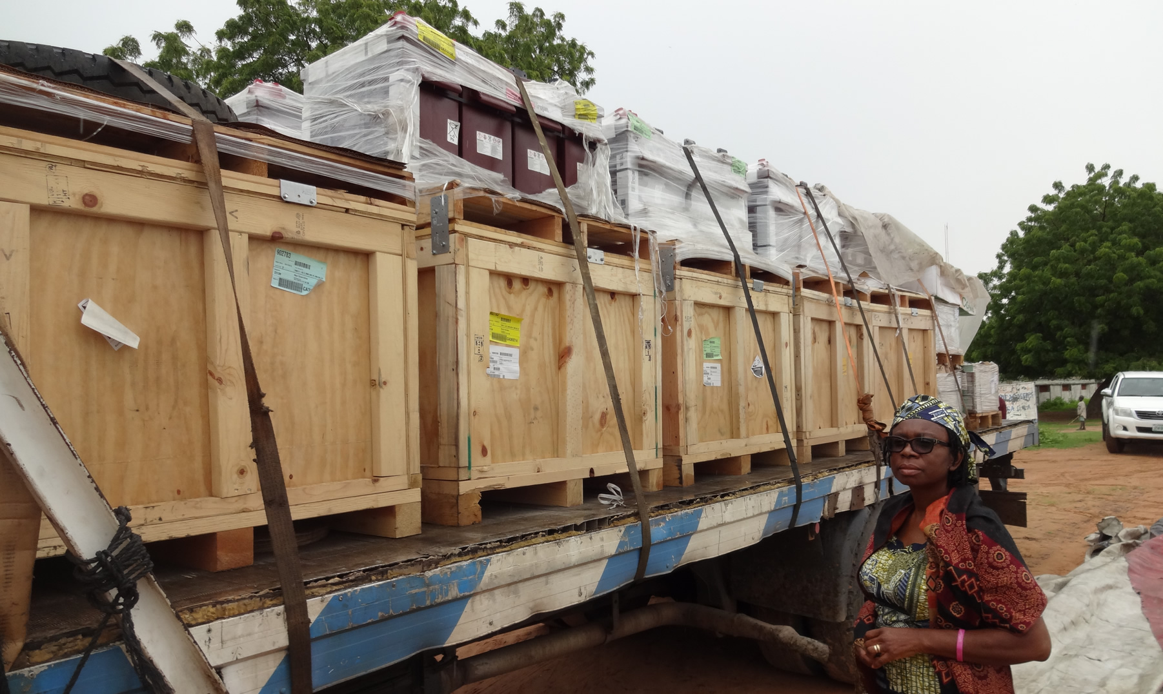
Off-loading some equipment at Gombe state site
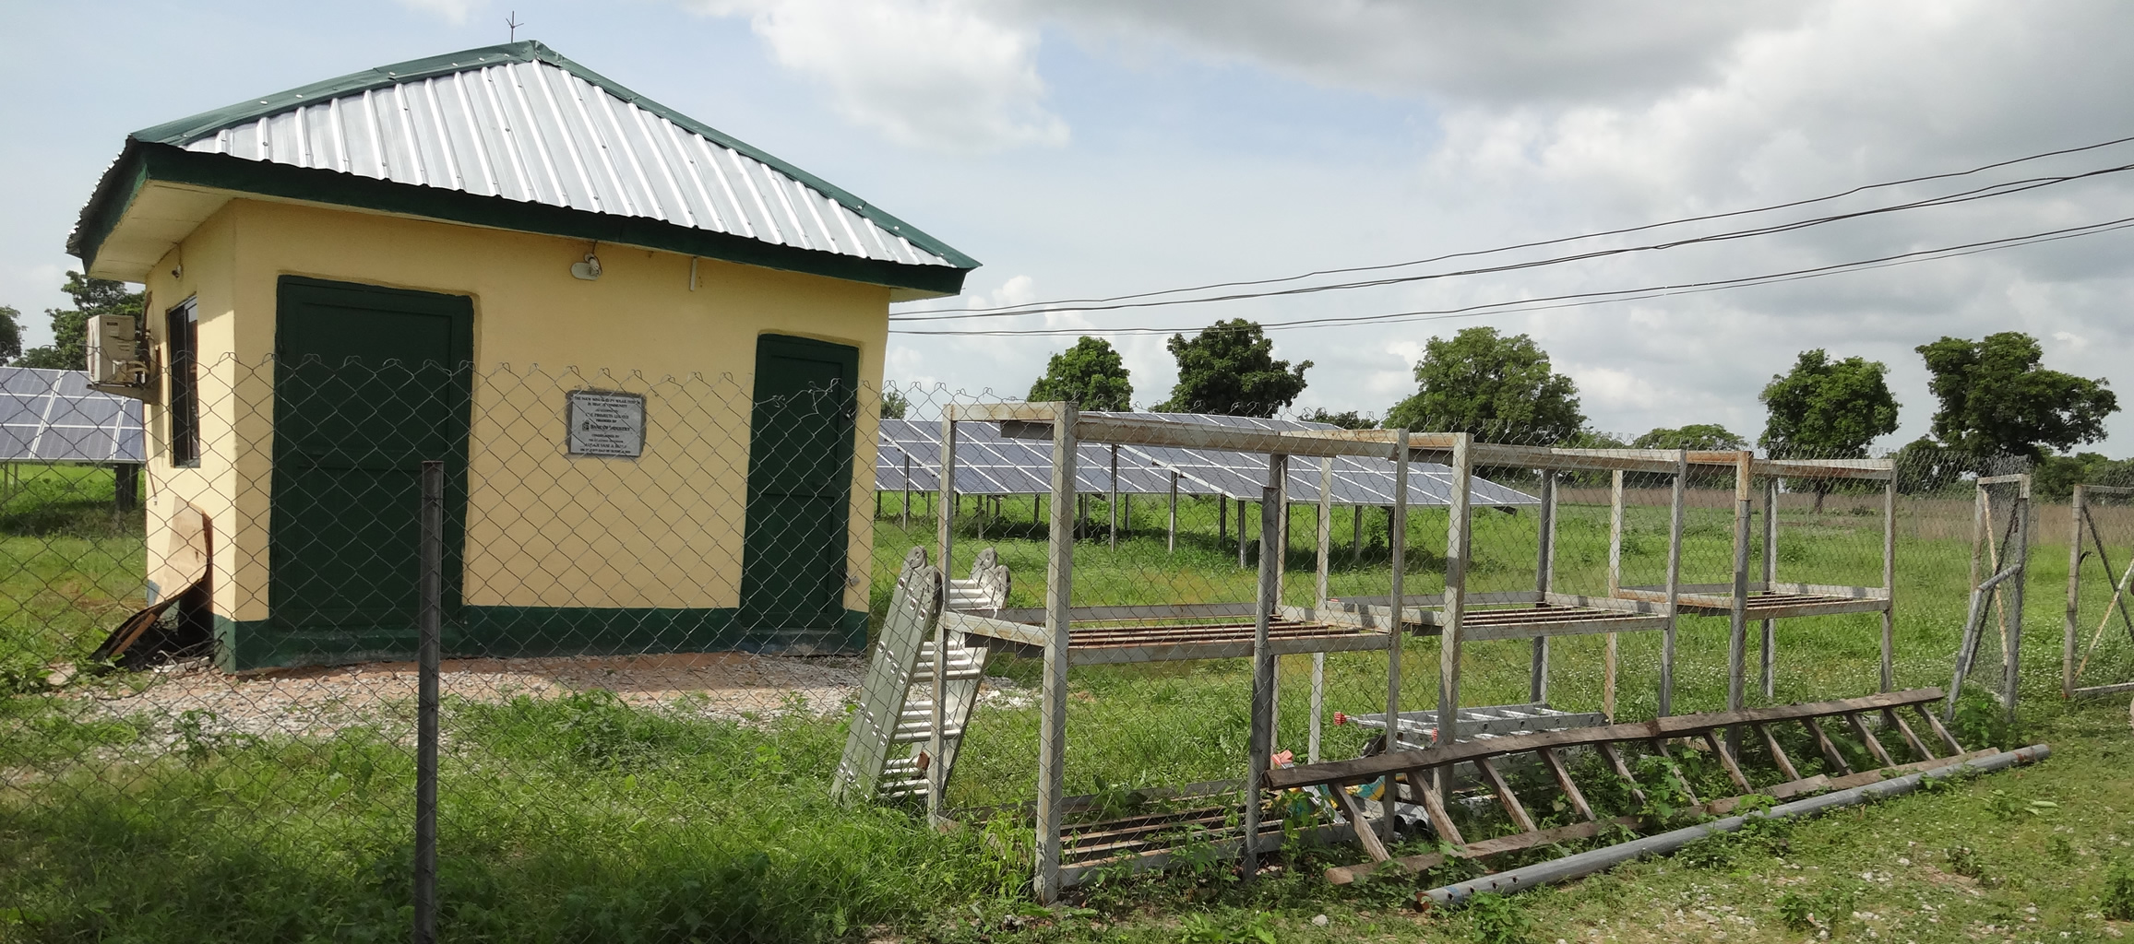
This is how the finished solar power house will look like. This is an initial pilot executed by Niger State government and BOI.

